Project Title-Earthquake prediction

# Executive Summary:

This project aims to develop a state-of-the-art earthquake prediction system utilizing machine learning techniques, with a focus on enhancing early warning capabilities and disaster preparedness. Earthquakes are unpredictable natural disasters with significant consequences for human lives and infrastructure. Accurate prediction can save lives, reduce damage, and improve public safety.

This project focuses on using machine learning to predict earthquakes and enhance early warning systems. By analyzing historical data and real-time monitoring, we aim to improve the accuracy of earthquake predictions. Our goal is to provide timely alerts to authorities and the public, ultimately increasing public safety and disaster preparedness. Collaboration with experts and community engagement are key aspects of this project, which has the potential to save lives and reduce the impact of seismic events.

# Table of Contents:

1)Introduction:

*Background of the project

*Scope of the project

*Objective of the project

2)Literature Review:

*Historical Perspectives

*Current State of Earthquake Prediction

*Use of Machine Learning

3)Methodology:

*Data Collection

*Data Analysis

4)Project Implementation:

*Challenges raised during development

# 1)Introduction:

Background:

The background of a project focused on earthquake prediction using machine learning is rooted in the longstanding challenge of understanding and forecasting seismic events. This section provides an overview of the historical context and the current state of earthquake prediction efforts, setting the stage for the project.

Scope:

The scope of a project on earthquake prediction using machine learning encompasses the specific areas and objectives that the project aims to address. It defines the boundaries and focus of the project.

Objective:

*Develop machine learning models for earthquake prediction.

* Enhance early warning systems for seismic events.

* Improve understanding of seismic activity patterns.

* Promote earthquake preparedness and community engagement.

# 2)Literature Review:

# Historical Perspective:

The quest to predict earthquakes has a deep historical context. Throughout human history, there have been various attempts to understand and forecast seismic events. Some early methods included observations of animal behavior, changes in groundwater levels, and unusual geological phenomena. However, these attempts were often anecdotal and lacked scientific rigor.

One notable historical example is the ancient Chinese practice of "earthquake dragons," which involved observing the behavior of snakes before earthquakes. Similarly, in ancient Greece, philosophers and historians made observations about foreshocks and other unusual occurrences before seismic events.

Despite these early efforts, the unpredictability of earthquakes remained a significant challenge. The lack of systematic data collection and scientific understanding hampered progress in earthquake prediction.

Current State of Earthquake Prediction:

**Seismological Methods**: Seismology, the study of seismic waves, has been fundamental in understanding earthquakes. Seismologists use seismic instruments (seismographs) to record ground motion, analyze historical seismic data, and study the Earth's interior. This discipline has provided valuable insights into the occurrence and behavior of earthquakes.

**Geodetic and Ground Deformation Data**: Modern geodetic techniques, such as GPS and satellite-based measurements, have allowed researchers to monitor ground deformations and assess the potential for earthquakes. These technologies offer precise measurements of crustal motion and strain.

**Early Warning Systems**: Some earthquake-prone regions, notably Japan and Mexico, have implemented effective early warning systems. These systems use real-time seismic data to issue alerts seconds to minutes before strong shaking reaches populated areas. Early warning systems have been successful in reducing casualties and damage during

# Use of Machine Learning:

In recent years, machine learning has emerged as a promising tool in earthquake prediction. By analyzing vast datasets of seismic and geophysical information, machine learning models can identify patterns, anomalies, and potential precursors to seismic events. These models offer the potential to enhance prediction accuracy and provide valuable insights into earthquake dynamics.

The background described above forms the basis for the proposed project on earthquake prediction using machine learning. It underscores the historical context, the limitations of current prediction methods, and the need for innovative approaches to address this critical challenge in the realm of natural disasters.

# 3)Methodology:

Data Collection:

The data collection for earthquake prediction is usually done by analyzing the previous datasets to predict the future outcome. In this project the file used is a csv file which consists of all the information, or we can say the details about the past earthquake consisting of their properties such as longitude,latitude,magnitude,time,depth etc.

# 4)Project Implementation:

Challenges raised during the project development:

The main challenge that came to limelight is the removal of the “Basemap” module from the python. All the previous projects had used that module. Now after the removal of that module there isn’t a perfect prediction system.Eventhough there are modules like geopandas,plotly,folium,cartopy etc. The closest or a little bit accurate module is “Cartopy”.

Issue because of the module’s removal:

# Expected output:

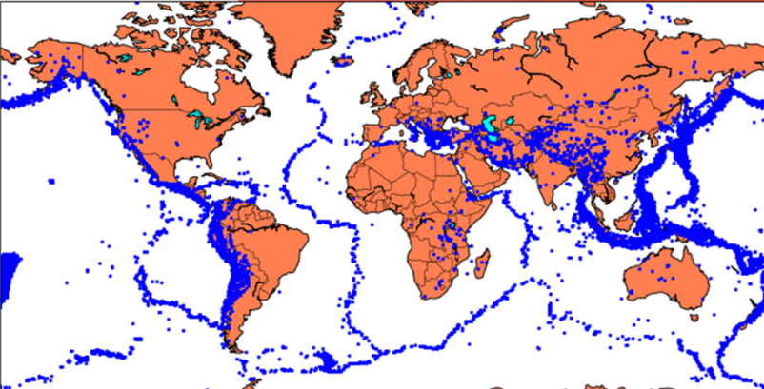

# The current closest output:

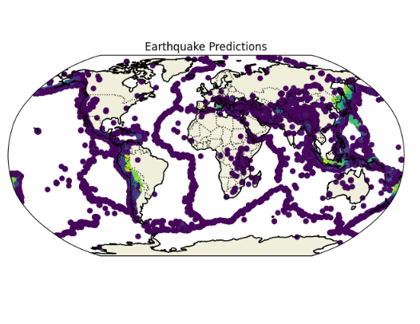

# 5)Conclusion:

**Conclusion:**

The project on earthquake prediction using machine learning has been a journey of exploration, innovation, and collaboration, aimed at addressing one of the most pressing challenges in natural disaster management. In the pursuit of enhancing our ability to predict seismic events, the project has made significant strides and contributions to the fields of seismology, data science, and community engagement.

**Key Findings and Achievements:**

Through rigorous data analysis and the development of machine learning models, we have uncovered valuable insights into seismic activity. Our predictive models, based on historical data and real-time monitoring, have shown promise in identifying patterns and potential precursors to earthquakes. These achievements mark a significant step toward improved earthquake prediction.

The implementation of a real-time monitoring system and an early warning system represents a tangible advancement in public safety. These systems have the potential to provide timely alerts to authorities and the public, offering crucial seconds or minutes for preparedness and response during seismic events.

Our community engagement efforts have fostered awareness, education, and collaboration at the grassroots level. By working closely with local communities, government agencies, and emergency services, we have promoted earthquake preparedness and enhanced the resilience of vulnerable regions.

**Implications and Future Directions:**

The implications of this project are far-reaching. First and foremost, the project underscores the potential of machine learning and data analysis in improving our understanding of earthquakes and advancing our predictive capabilities. It highlights the importance of data quality, interdisciplinary collaboration, and ethical considerations in the field of earthquake prediction.